ABSTRACT:
SRAM or Static Random Access Memory is a form of semiconductor memory widely used in electronics, microprocessor and general computing applications. This form of semiconductor memory gains its name from the fact that data is held in there in a static fashion, and does not need to be dynamically updated as in the case of DRAM memory. While the data in the SRAM memory does not need to be refreshed dynamically, it is still volatile, meaning that when the power is removed from the memory device, the data is not held, and will disappear.
INTRODUCTION:
In this lab experiment our objective was to learn the implementation and operation of SRAM cell with inverter latch and 6 transistor based basic SRAM cell.

A basic SRAM cell with inverter latch had been implemented in this lab experiment. It was used to store logic ‘0’ or ‘1’. We had learned the steps of Reading and Writing a ‘1’ or ‘0’ into a SRAM .

THEORY AND METHODOLOGY:

SRAM memory basics
There are two key features to SRAM - Static random Access Memory, and these set it out against other types of memory that are available:
- The data is held statically: This means that the data is held in the semiconductor memory without the need to be refreshed as long as the power is applied to the memory.
- SRAM is a form of random access memory: A random access memory is one in which the locations in the semiconductor memory can be written to or read from in any order, regardless of the last memory location that was accessed.
The circuit for an individual SRAM memory cell comprises typically four transistors configured as two cross coupled inverters. In this format the circuit has two stable states, and these equate to the logical "0" and "1" states. In addition to the four transistors in the basic memory cell, and additional two transistors are required to control the access to the memory cell during the read and write operations. This makes a total of six transistors, making what is termed a 6T memory cell. Sometimes further transistors are used to give either 8T or 10T memory cells. These additional transistors are used for functions such as implementing additional ports in a register file, etc for the SRAM memory.Although any three terminal switch device can be used in an SRAM, MOSFETs and in particular CMOS technology is normally used to ensure that very low levels of power consumption are achieved. With semiconductor memories extending to very large dimensions, each cell must achieve a very low levels of power consumption to ensure that the overall chip does not dissipate too much power.

SRAM memory cell operation
The operation of the SRAM memory cell is relatively straightforward. When the cell is selected, the value to be written is stored in the cross-coupled flip-flops. The cells are arranged in a
matrix, with each cell individually addressable. Most SRAM memories select an entire row of cells at a time, and read out the contents of all the cells in the row along the column lines.While it is not necessary to have two bit lines, using the signal and its inverse, this is normal practice which improves the noise margins and improves the data integrity. The two bit lines are passed to two input ports on a comparator to enable the advantages of the differential data mode to be accessed, and the small voltage swings that are present can be more accurately detected.Access to the SRAM memory cell is enabled by the Word Line. This controls the two access control transistors which control whether the cell should be connected to the bit lines. These two lines are used to transfer data for both read and write operations.

SRAM memory applications
There are many different types of semiconductor memory that are available these days. Choices need to be made regarding the correct memory type for a given application. Possibly two of the most widely used types are DRAM and SRAM memory, both of which are used in processor and computer scenarios. Of these two SRAM is a little more expensive than DRAM. However SRAM is faster and consumes less power especially when idle. In addition to this SRAM memory is easier to control than DRAM as the refresh cycles do not need to be taken into account, and in addition to this the way SRAM can be accessed is more exactly random access. A further advantage if SRAM is that it is more dense than DRAM.As a result of these parameters, SRAM memory is used where speed or low power are considerations. Its higher density and less complicated structure also lend it to use in semiconductor memory scenarios where high capacity memory is used, as in the case of the working memory within computers.

Apparatus:

1) PMOS : 2-pieces
2) NMOS : 4-pieces
3) IC 7404 (Inverter) : 1-pieces
Precautions:
Before turning on the DC source we carefully checked and rechecked whether the circuit had been implemented correctly. We checked for short circuits and whether the LEDs were working properly. We tried avoiding all errors during the whole experiment.

Experimental Procedure:

In this lab experiment we had observed the reading and writing of a basic SRAM cell in this lab experiment.

- In order to write and read a ‘1’ in the SRAM cell:

1) At first we had connected the circuit shown in Fig.1 .

2) A high value (‘1’) was given in the access or pass transistors. The PMOS remained ‘Off’ and so, writing was disabled.

3) Then we gave a high value (‘1’) in the bit line-A and low value (‘0’) in the bit line bar -A*. Usually, A would been inverted to A*.

4) We enabled the access transistors by giving a low value (‘0’) and so ‘1’ had been written in the cell.

5) Again we disabled the access transistors by giving a high value (‘1’) and removed the value of the bit lines, A and A*.

6) We then read the value from the latch observed that ‘1’ had been saved in the SRAM cell.

B. In order to write and read a ‘0’ in the SRAM cell:

1) We connected the circuit shown Fig.1 .
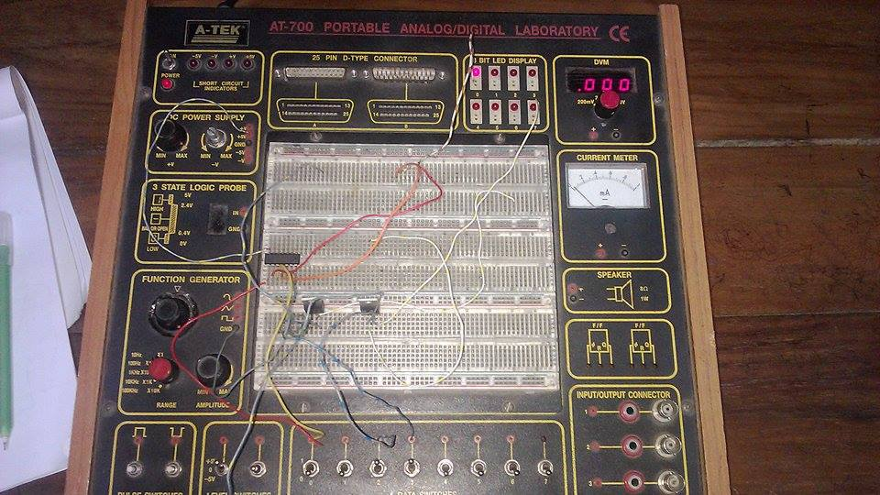

2) We gave a high value (‘1’) in the access or pass transistors. They were PMOS and so they remained ‘Off’ and writing was disabled.

3) Then we gave a low value (‘0’) in the bit line (A) and high value (‘1’) in the bit line bar (). Under normal condition the A would have been inverted to A*.

4) The access transistors had been enabled by giving a low value (‘0’). After that ‘0’ had been written in the cell.

5) Then again we disabled the access transistors by giving a high value (‘1’) and removed the value of the bit lines, A and A* .

6) At last, we read the value from the latch observed that ‘0’ had been saved in the SRAM cell.

Simulation:
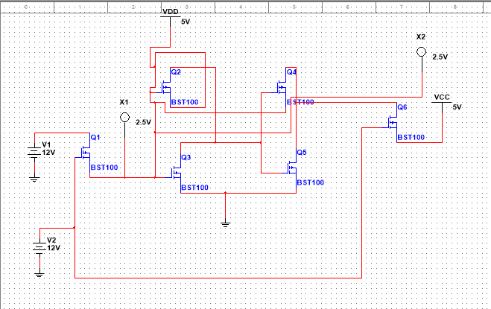

Fifure:SRAM Cell
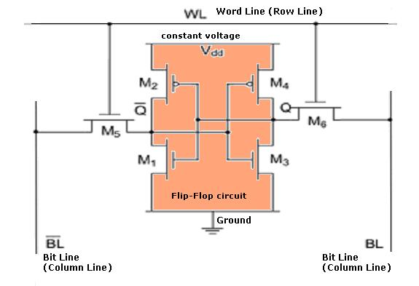

Standby: If the word line is not asserted, the access transistors M5 and M6 disconnect the cell from the bit lines. The two cross-coupled inverters formed by M1 - M4 will continue to reinforce each other as long as they are disconnected from the outside world.
Read operation: We assume that the content of the memory is a 1, stored at Q. The read cycle is started by pre-charging both the bit lines to a logical 1, then asserting the word line WL, enabling both the access transistors. The second step occurs when the values stored in Q and -Q are transferred to the bit lines by leaving BL at its pre-charged value and discharging -BL through M1 and M5 to a logical 0. On the BL side, the transistors M4 and M6 pull the bit line toward VDD, a logical 1. If the content of the memory was a 0, the opposite would happen and -BL would be pulled toward 1 and BL toward 0.
Write operation: The value to be written is applied to the bit-lines to start the writing operation. To write a 0, we would apply a 0 to the bit lines, i.e. setting -BL to 1 and BL to 0. This is similar to applying a reset pulse to a SR-latch, which causes the flip-flop to change state. A 1 is written by inverting the values of the bit lines. WL is then asserted and the value that is to be stored is latched in. Note that the reason this works is that the bit line input-drivers are designed to be much stronger than the relatively weak transistors in the cell itself, so that they can easily override the previous state of the cross-coupled inverters. Careful sizing of the transistors in an SRAM cell is needed to ensure proper operation.
To work properly and to ensure that the data in the cell will not be altered, the SRAM must be supplied by a Vdd (power supply) that will not fluctuate beyond plus or minus five or ten percent of the main VCC. If the cell is not disturbed, a lower voltage level is acceptable to ensure that the cell will correctly keep the data. In that case, the SRAM is set to a retention mode where the power supply is lowered, and the part is no longer accessible.
The power consumption of SRAM varies depending on how frequently it is accessed; it can be as power-hungry as dynamic RAM, when used at high frequencies. On the other hand, SRAM used at a somewhat slower pace, such as in applications with moderately clocked microprocessors, draw very little power and can have nearly negligible power consumption when sitting idle.
Discussion & Conclusion:
An SRAM cell has three different states it can be in:
1. Standby where the circuit is idle
2. Reading when the data has been requested
3. Writing when updating the contents

REFERENCE:
1/http://www.radio-electronics.com/info/data/semicond/memory/sram-memory-basics-tutorial.php
http://www.eeherald.com/section/design-guide/esmod15.html
2/Lab manual.

